

MagicalWand.net

12.06.2020

ZhuoXuan(Eric) Jiang

Larry Wu

Amethyst He

Lily Yang

1. **Introduction**

Mission Statement

As a MagicWand Company, our mission is making sure each customer has an unique magic wand according to their characteristics and demands, become the most powerful witches and wizards. Every wizard on the earth can order their dreamy magic wand on our website. Be careful! We only welcome the talent wizards; no muggle is allowed to buy the magic wand. Importantly, we will lead the world to become a brand-new magic world!

Executive Summary

During this period of isolation, an increasing amount of people do business, get educations, or shop online. It is reasonable for wizards to have websites where they can purchase wands. We want to make a fully functional, online version of Ollivenders Magical Wand Shop. The shop is going to simple, and easily accessible. Users should be able to browse through available wands easily, search for wands with their compositions, adding wands to shopping carts whenever they want. However, we want to make sure not muggles wondering around the websites will never be able to use it. We are going to require user to register before they want to use it, and we will use verification question regarding spells every time user try to login. The website provides various shipments for users to select from when they try to purchase. For instance, wands could be delivered by an owl, or someone could deliver it expressly riding a broomstick. And users would be able to visit history purchases when they would like to.

1. **System Features**

Project Features List Template

|  |  |  |  |  |
| --- | --- | --- | --- | --- |
| **Final Overall System Features** | **Category** | **Possible Points** | **Points** | **Comments / Code Files** |
| **Documentation (10 total points)** | | | | |
| Executive Summary (up to 1 page) | Core | 2 | 2 |  |
| System Features (2 pages) | Core | 2 | 2 |  |
| Walkthrough with screenshots (up to 10 pages) | Core | 6 | 6 |  |
|  | | | | |
| **Hosting (10 total points)** | | | | |
| Running on cloud server | Advanced | 10 | 10 |  |
|  | | | | |
| **Main/Home Page (up to 14 total points)** | | | | |
| Search for a product by name | Core | 1 | 1 |  |
| Browse products by category | Core | 1 | 1 |  |
| List products (by search/browse) | Core | 1 | 1 |  |
| List products with image | Core | 1 | 1 |  |
| Page header with menu | Basic | 1 | 1 |  |
| Page header shows current logged in user | Basic | 1 | 1 |  |
| Dynamic products on page based on sales | Basic | 2 | 2 |  |
| Improved UI (user-friendly, images, etc.) | Basic | 2 | 2 |  |
| Product recommendation based on user | Advanced | 4 |  |  |
|  | | | | |
| **Shopping Cart (up to 8 total points)** | | | | |
| Add to shopping cart | Core | 1 | 1 |  |
| View shopping cart | Core | 1 | 1 |  |
| Update quantity (with data validation) | Basic | 1 | 1 |  |
| Remove item from shopping cart | Basic | 1 | 1 |  |
| Improved formatting/UI (e.g. in header bar) | Basic | 1 | 1 |  |
| Cart stored in database between sessions | Basic | 3 | 3 |  |
|  | | | | |
| **Checkout (up to 9 total points)** | | | | |
| Checkout with customer id | Core | 1 | 1 |  |
| Checkout with payment/shipment info | Basic | 2 | 2 |  |
| Checkout with data validation | Basic | 2 | 2 |  |
| Multiple shipments per order supported | Advanced | 2 |  | Note: Requires DB change. |
| Calculate taxes/shipping (by items/state) | Advanced | 2 |  | Note: Requires DB change. |
|  | | | | |
| **Product Detail Page (up to 2 total points)** | | | | |
| Product detail page and item description | Core | 1 | 1 |  |
| Product detail has an image from database | Core | 1 | 1 |  |
|  | | | | |

|  |  |  |  |  |
| --- | --- | --- | --- | --- |
| **User Accounts/Login (up to 12 total points)** | | | | |
| Create user account page | Basic | 2 | 2 |  |
| Create account with data validation | Basic | 2 | 2 |  |
| Edit user account info (address, password) | Basic | 2 | 2 |  |
| Login/logout | Core | 1 | 1 |  |
| Register user/Forgot password email | Advanced | 4 |  |  |
| Page listing all orders for user | Core | 1 | 1 |  |
|  | | | | |
| **Product Reviews (up to 5 total points)** | | | | |
| Ability to enter a review on a product | Basic | 2 | 2 |  |
| Display product review on product detail page | Basic | 1 | 1 |  |
| Restrict to one review per user on item purchased | Advanced | 2 |  |  |
|  | | | | |
| **Warehouses/Inventory (up to 5 total points)** | | | | |
| Display item inventory by store/warehouse | Basic | 2 | 2 |  |
| Edit item inventory by store/warehouse | Advanced | 3 | 3 |  |
|  | | | | |
| **Administrator Portal (up to 19 total points)** |  |  |  |  |
| Secured by login | Core | 1 | 1 |  |
| List all customers | Core | 1 | 1 |  |
| List report showing total sales/orders | Core | 1 | 1 |  |
| Report with a graph | Advanced | 3 |  |  |
| Add new product | Basic | 2 | 2 |  |
| Update/delete product | Basic | 2 | 2 |  |
| Change order status/ship order | Basic | 1 | 1 |  |
| Upload a photo to file system for product | Advanced | 2 |  |  |
| OR: Upload a photo to database for product | Advanced | 4 |  |  |
| Database restore with SQL script | Basic | 2 |  |  |
| Add/update warehouse, customer | Basic | 2 |  |  |
|  |  |  |  |  |
| **Database System/General** |  |  |  |  |
| Implement some validation using triggers | Advanced | 2 |  |  |
| Use AJAX for some pages | Advanced | 4 |  |  |
| User interface and navigation/usability |  | Up to 5 |  |  |
| *Others (your suggestions)* |  | Up to 5 |  |  |
|  |  |  |  |  |
|  |  |  |  |  |
|  |  |  |  |  |
|  |  |  |  |  |
| **Total: (out of 50 with maximum of 10 bonus marks. i.e. 60 points out of 50 is max.)** |  | Total: | 69/50 |  |

1. **User Walkthrough**

* *Walkthrough*

Please use this link for the walkthrough of MagicWand.net:

Admin Users:

Britney Bentley userid: ben password: test1

NonAdmin Users:

Brenda Kelly userid: kelly password: test2

Jennifer Barber userid: barber password: test3

Sandra Jackson userid: jack password: test4

Harry Suarez userid: harry password: test5

* *HomePage*

Welcome to MagicWand.net! Here is our home page with the menu of our website with beautiful **Hedwig's Theme by The City of Prague Philharmonic Orchestra**. There are several options on the menu. If you are first to our website, you can first click ‘Login’ to login to your account, and then click the ‘Begin Shopping’ to start your journey in shopping wand. However, if you are our old customer, who want to change to your personal information, you can click ‘Customer Info’ to edit your personal information.

**Before login:**

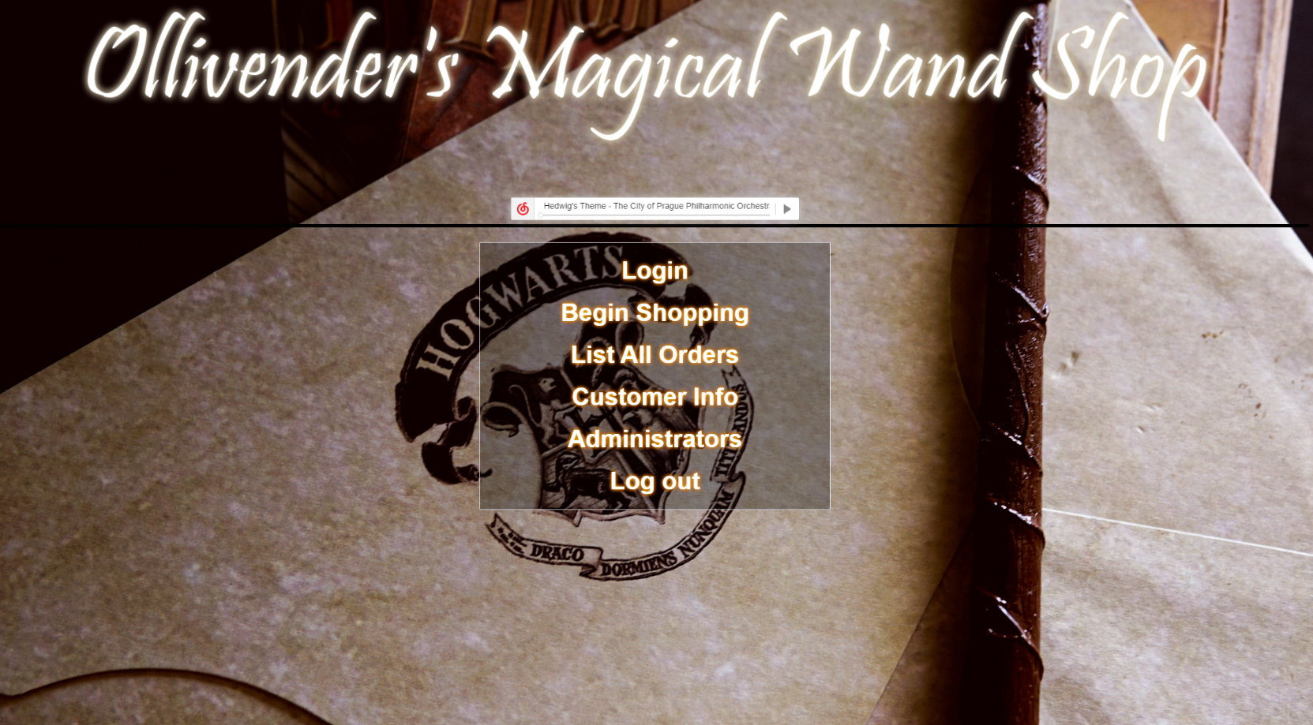

* *Customer Login*

|  |  |  |
| --- | --- | --- |
| 1 | After you click the ‘Login’, you will come to our next page! Which is the customer login page! In this page, you need to enter your username and password in order to login to your account. As we mention before, if you are our new customer without a username and password, you can register for your new account by clicking ‘**Register your accoun**t’. |  |
| 2  (create account) | After you click ‘Register your password’ from the login page, then you will come to create account page which you can set up your username and password with **maximum 10 letters and minimum 1 letter**. However, if your suddenly realize that you already have an account, then you also can go back to the login page by clicking ‘**Sign in**’ beside ‘already have an account?’. After your account is signed up, you will go back to the login page automatically. If the username has been used by someone else, it will show **username is existed**. |  |
| 3.  (forget password) | You can enter your email and then click submit, if your email is matched then you will see your password, you can click ‘LOGIN’ to go back to the login page. However, if your email does not match, then you can click ‘GO BACK’ to re-enter your email address. |  |
| 4 | After Login, you will see the main page will show differently. And then you can click ‘Begin Shopping’ to go to our product page. |  |

* *Start Your Shopping*

|  |  |  |
| --- | --- | --- |
| 1 | Here is our shopping page with a list of al of our products. As you can see, we list our 5-top sale by using scrolling those wand’s images. During the time it scrolls, when you stop your mouse on any of it, it will stop, when your mouse is left, then it will start scrolling again. |  |
| 2 | You can search for the product from all the type, or you can search it by different type such as Springy. Also, you can see the product image, product name, category and price by keep scrolling down. If you know this product is exactly what you want then you can click ‘add to cart’, then it will show up on your shopping cart later. |  |
| 3 | If you want to know more information the product you are interested, then you can click the product name of that product, for example click ‘ACACIA WAND’, then you will see the detail description, product id, the price of the wand, and how many we still have in stock in our product introduction page. |  |
| 4 | It will highlighted and underscore when your mouse move to the description, or the ‘Add to Cart’ and ‘Continue Shopping’ |  |
| 5 | On the bottom of the same page as above, you can look at the reviews from the other customer about this wand. If you bought this wand before, you can rate it and write a review toward it. But you will need to confirm your customer ID and password again in order to rate the product. |  |
| 6 | After you add your product to your shopping cart, you can see a list of product that you want to buy either today or last time the product you add to the cart. You also can click ‘+’ or ‘-’ to increase or decrease the number of product you want, or click ‘REMOVE’ if you do not want this product. You can either checkout or continue shopping after you look at your shopping cart. |  |
| 7 | If you click ‘CHECKOUT’, you will need confirm your customer id and password again, you can also reset if you enter incorrectly. |  |
| 8 | After you confirm your customer ID and password, you will go to your order summary page, and you can see your order summary table, your previous shipping address that store in our system. You can click the link to change your shipping address or finish your payment. |  |
| 9 | If you click the ‘change your shipping address’, then it will take you to the edit address page. (Attention! You must follow the format for the value you enter, if you enter something else or leave it empty, then you are not allowed to submit) |  |
| 10 | Then now you are successfully edit your shipping address |  |
| 11 | You can click ‘Customer Info’ to take a look with your new shipping address now |  |

* *Payment*

|  |  |  |
| --- | --- | --- |
| 1 | After you click ‘Pay for your wand’ in order summary page, you will go to the payment page.  You can choose either credit card or Paypal to finish your payment.  Attention: the system only accept the 16 digit credit card number and 3 digits CVV. You are not allow to enter anything else as letter and symbol in credit card number field |  |
| 2 | It will link to PayPal after you choose a way to ship and pay for the Shipping |  |
| 3 | After your payment, you will come to the thank you page with your order number and the customer name. |  |